**PIZZA SALES SQL QUERIES**

## A. KPI’S

**1. Total Revenue**

SELECT sum(total_price) AS Total_Revenue FROM pizza_sales

**Output**

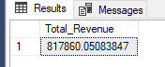

**2. Average Order value**

SELECT sum(total_price)/ count(DISTINCT order_id)AS Avg_Order_Value FROM pizza_sales

**Output**

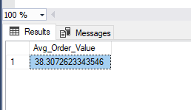

**3. Total Pizzas Sold**

SELECT sum(quantity) AS Total_Pizza_Sold FROM pizza_sales

**Output**

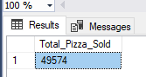

**4. Total Pizzas Order**

SELECT COUNT(DISTINCT order_id)AS Total_Orders FROM pizza_sales

**Output**

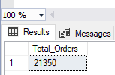

**5. Average Pizzas Per Order**

SELECT CAST( CAST (sum(quantity) AS decimal(10,2)) /

CAST (count (DISTINCT order_id) AS DECIMAL (10,2))AS DECIMAL (10,2)) AS Avg_Pizzas_Per_Order FROM pizza_sales

**Output**

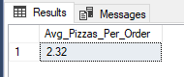

**B. Daily Trend For Total Order**

SELECT DATENAME(DW, order_date) AS order_day,

COUNT(DISTINCT order_id) AS Total_orders

from pizza_sales

GROUP BY DATENAME(DW, order_date)

**Output**

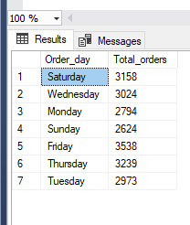

**C. Monthly Trend For Total Orders**

SELECT DATENAME(MONTH, order_date) AS Order_Month, count(distinct order_id) AS Total_Order

FROM pizza_sales

GROUP BY order_date

**Output**

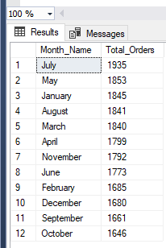

**D. Pizza Category by Total Revenue**

SELECT pizza_category,cast( sum(total_price)as decimal(10,2)) AS Total_Revenue

FROM pizza_sales

GROUP BY pizza_category

ORDER BY Total_Revenue DESC

**Output**

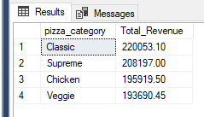

**E. Pizza Category by Total Quantity sold**

SELECT pizza_category, count(quantity) AS Total_Quantity_Sold

FROM pizza_sales

GROUP BY pizza_category

ORDER BY Total_Quantity_Sold DESC

**Output**

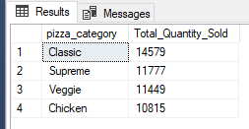

**F. % Of Sales by Pizza Category**

SELECT pizza_category, cast (sum(total_price)as decimal (10,2)) AS Total_Revenue,

count (Distinct order_id) AS Total_Order,

CAST (cast(sum(total_price)* 100 AS DECIMAL (10,2)) /

(SELECT cast (sum(total_price)AS DECIMAL (10,2))FROM pizza_sales)AS DECIMAL (10,2))AS PCT

FROM pizza_sales

GROUP BY pizza_category

**Output**

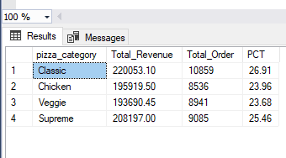

**G. % of sale by Pizza size**

SELECT pizza_size, cast (sum(total_price)as decimal (10,2)) AS Total_Revenue,

count (Distinct order_id) AS Total_Order,

CAST (cast(sum(total_price)* 100 AS DECIMAL (10,2)) /

(SELECT cast (sum(total_price)AS DECIMAL (10,2))FROM pizza_sales)AS DECIMAL (10,2))AS PCT

FROM pizza_sales

GROUP BY pizza_size

ORDER BY Total_Order DESC

**Output**

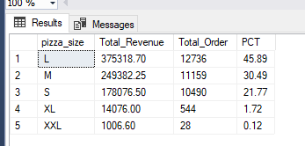

**H. Top 5 Pizzas by Total Revenue**

SELECT TOP 5 pizza_name, SUM(total_price)AS Total_Revenue

FROM pizza_sales

GROUP BY pizza_name

ORDER BY Total_Revenue DESC

**Output**

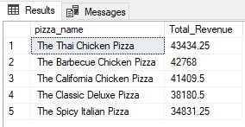

**I. Bottom 5 Pizzas by Total Revenue**

SELECT TOP 5 pizza_name, SUM(total_price)AS Total_Revenue

FROM pizza_sales

GROUP BY pizza_name

ORDER BY Total_Revenue ASC

**Output**

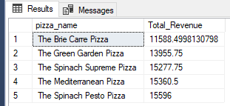

**J. Top 5 Pizzas by Total Pizzas Sold**

SELECT TOP 5 pizza_name, SUM(quantity)AS Total_Pizzas_Sold

FROM pizza_sales

GROUP BY pizza_name

ORDER BY Total_Pizzas_Sold DESC

**Output**

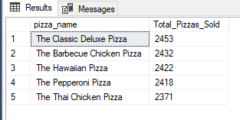

**K. Bottom 5 Pizzas by Total Pizzas Sold**

SELECT TOP 5 pizza_name, SUM(quantity)AS Total_Pizzas_Sold

FROM pizza_sales

GROUP BY pizza_name

ORDER BY Total_Pizzas_Sold ASC

**Output**

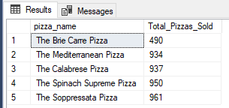

**L. Top 5 Pizzas by Total Orders**

SELECT TOP 5 pizza_name, COUNT(DISTINCT(order_id))AS Total_Orders

FROM pizza_sales

GROUP BY pizza_name

ORDER BY Total_Orders DESC

**Output**

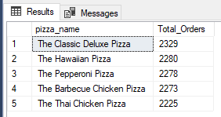

**M. Bottom 5 Pizzas by Total Orders**

SELECT TOP 5 pizza_name, COUNT(DISTINCT(order_id))AS Total_Orders

FROM pizza_sales

GROUP BY pizza_name

ORDER BY Total_Orders ASC

**Output**

